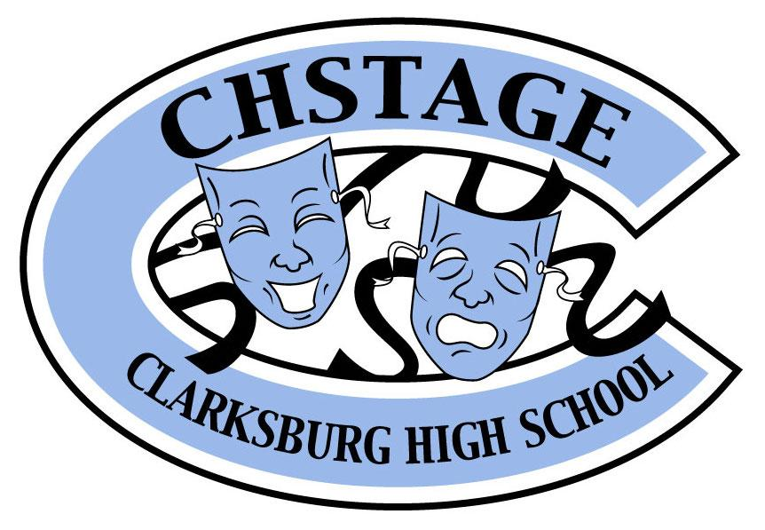
CHStage Supporting Cast Foundation
22500 Wims Road
Clarksburg, MD 20871
www.chstage.net
Non-Profit Federal Tax ID # 80-0688562

Program Advertising Form

Select Ad Size | Spring Show | Fall and Spring Shows
Full- Page 4.5x 8 | $85 | $150
Half Page 4.5x 4 | $50 | $85
Quarter Page - 2.25 x 2 | $25 | $45

Payment
Method of Payment: Check ☐ Money Order ☐ Pay online at CHStage.net□

*Please make checks payable to “CHStage Supporting Cast”

Business Name:
Contact Name:
Address:
Phone:
Email:

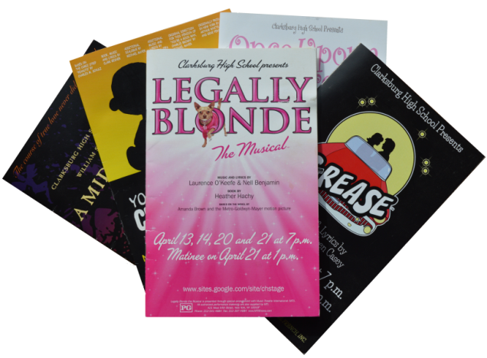
Please send your electronic ad copy to
CHStage@gmail.com by March 1, 2019

Please complete this form and send with
payment or pay online by March 1, 2019
to:
Clarksburg High School
Attention: Michelle Meyer
22500 Wims Road
Clarksburg, MD 20871

Send an e-mail to CHStage@gmail.com if you wish to arrange a personal pickup of the form and payment.

