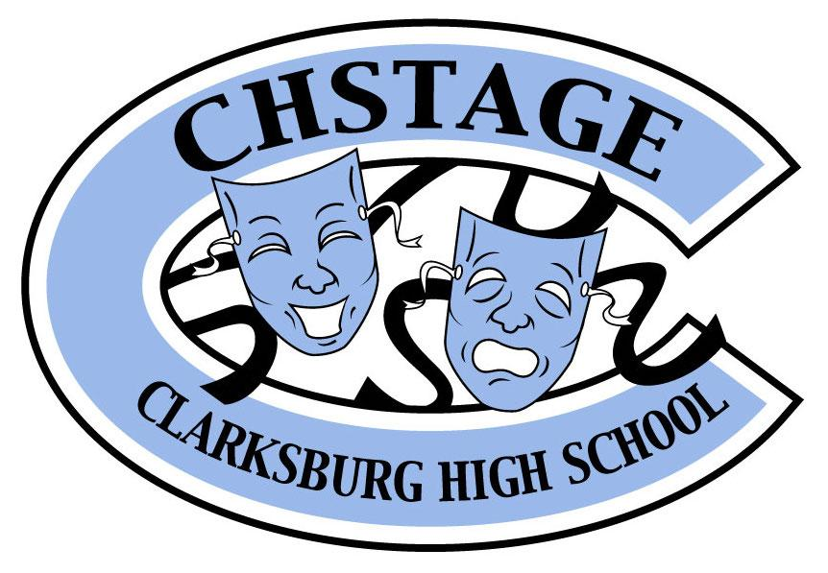
CHStage Supporting Cast Foundation
22500 Wims Road
Clarksburg, MD 20871
www.chstage.net
Non-Profit Federal Tax ID # 80-0688562

Shout-Outs
Full-page: | ☐ | $85
Half-page: | ☐ | $50
Quarter-page: | ☐ | $25

Please send your electronic shout-out copy to CHStage@gmail.com by March 1, 2019

Payment:
Form of Payment: Cash □ Check □ Money Order □ Paid Online @CHStage.net□
*Please make checks payable to CHStage Supporting Cast
Name:
Address:
Phone:
Email:

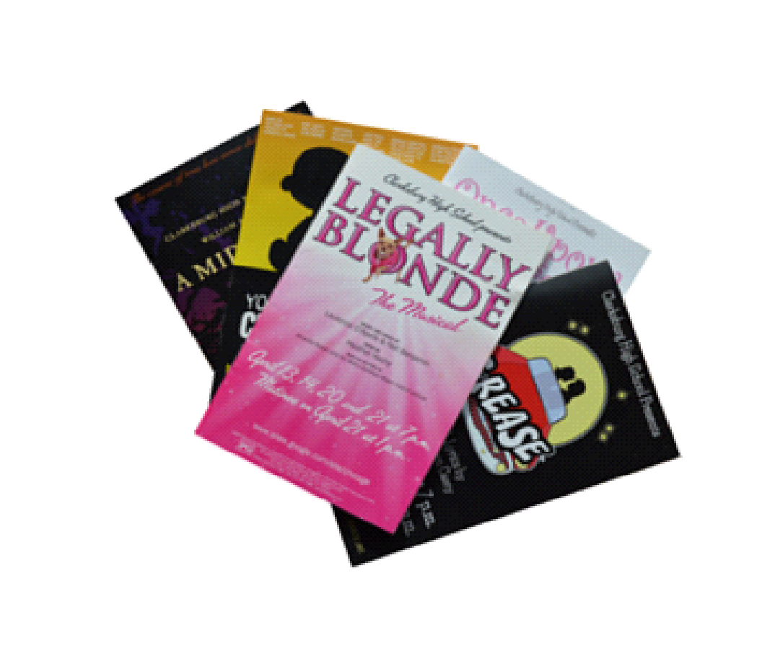
Please complete this form and send with payment
by March 1, 2019 to:
Clarksburg High School
Attention: Michelle Meyer
22500 Wims Road
Clarksburg, MD 20871

